Практическая работа №4
Тема: «Построение Машины вывода для Экспертной
Системы реляционного типа»

Цель: разработать модель экспертной системы, реализующей механизм вывода на основе реляционной базы знаний, для определения погодных условий в заданных городах в Windows Forms.

Ход работы
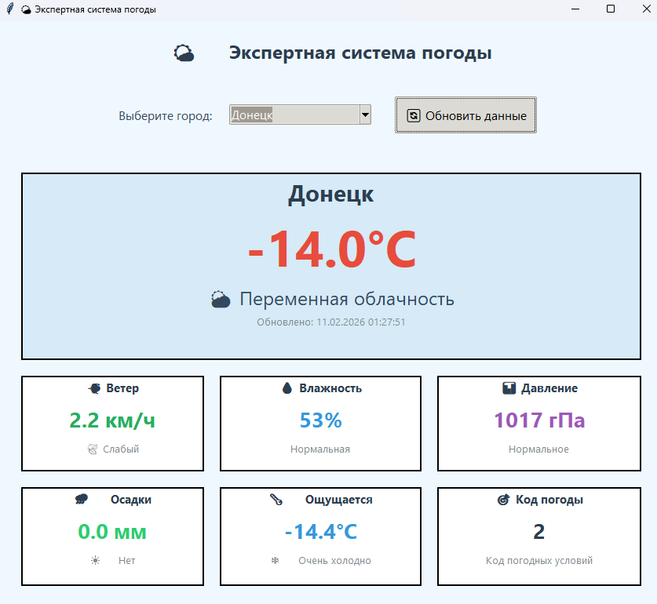
Рис. 1 – Донецк

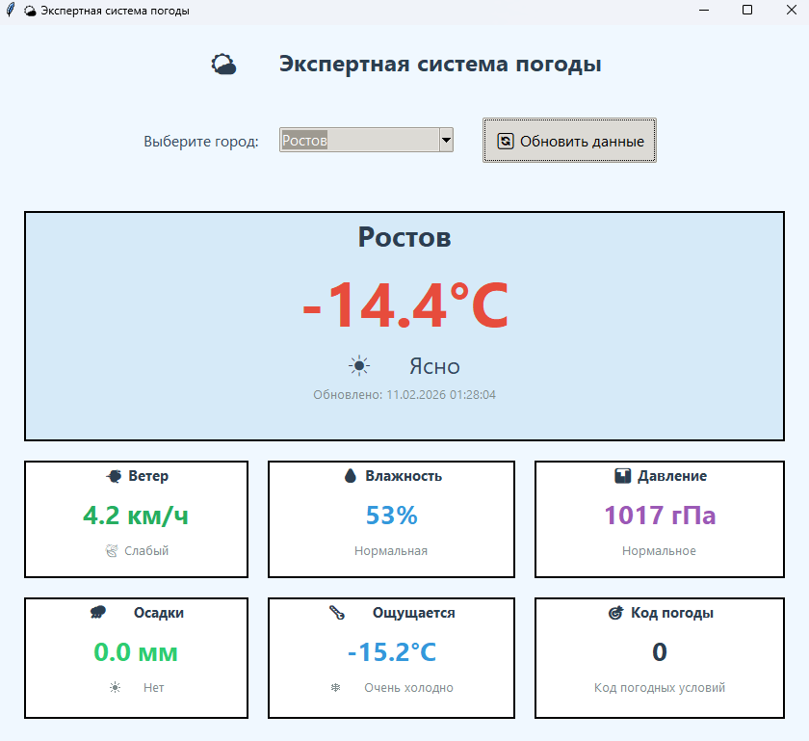
Рис. 2 – Ростов

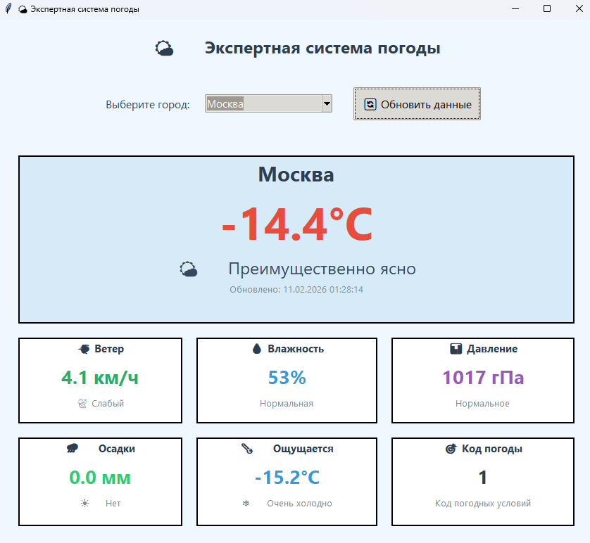
Рис. 3 – Москва

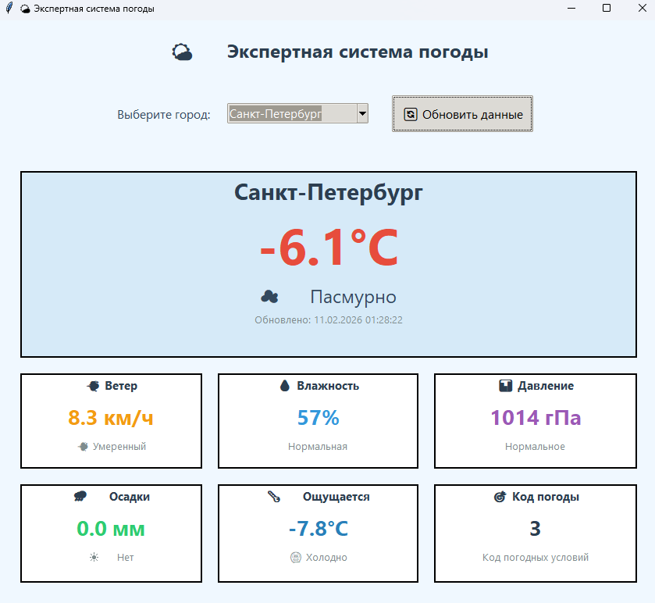
Рис. 4 – Санкт-Петербург

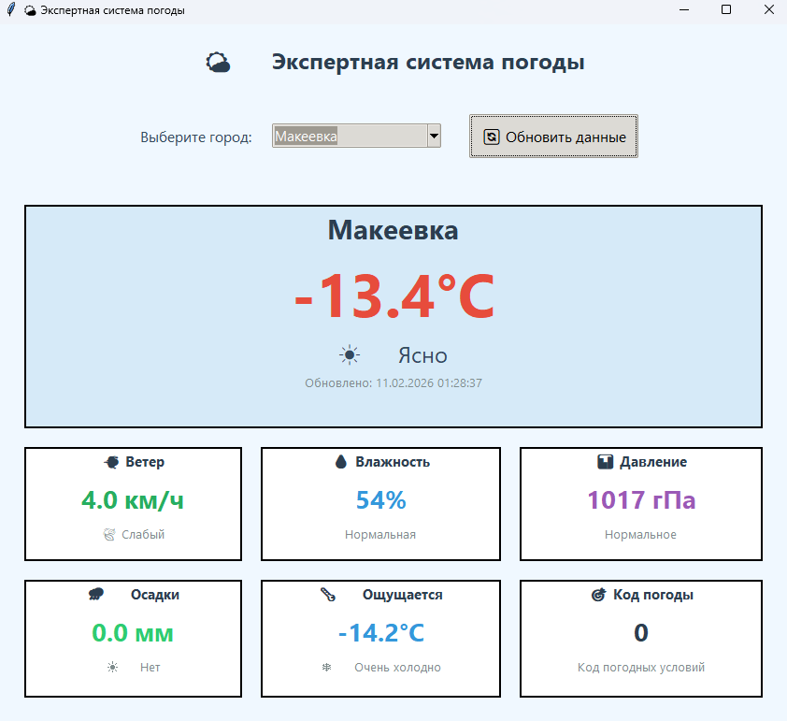
Рис. 5 – Макеевка

Приложение А:
import tkinter as tk
from tkinter import ttk, font
import requests
from datetime import datetime
import json

class WeatherExpertSystem:
def __init__(self, root):
self.root = root
self.root.title("🌤️ Экспертная система погоды")
self.root.geometry("850x750")
self.root.configure(bg='#f0f8ff')

self.style = ttk.Style()
self.style.theme_use('clam')
self.configure_styles()

self.cities = {
"Макеевка": {"lat": 48.0478, "lon": 37.9722},
"Донецк": {"lat": 48.0159, "lon": 37.8028},
"Ростов": {"lat": 47.2313, "lon": 39.7233},
"Москва": {"lat": 55.7558, "lon": 37.6173},
"Санкт-Петербург": {"lat": 59.9343, "lon": 30.3351}
}

self.create_widgets()

def configure_styles(self):
self.style.configure('Title.TLabel', font=('Segoe UI', 18, 'bold'), background='#f0f8ff', foreground='#2c3e50')
self.style.configure('City.TLabel', font=('Segoe UI', 12), background='#f0f8ff', foreground='#34495e')
self.style.configure('Card.TFrame', background='white', relief='solid', borderwidth=2)
self.style.configure('Value.TLabel', font=('Segoe UI', 14, 'bold'), background='white', foreground='#2c3e50')
self.style.configure('Param.TLabel', font=('Segoe UI', 10), background='white', foreground='#7f8c8d')
self.style.configure('WeatherCard.TFrame', background='#e8f4fc', relief='solid', borderwidth=2)
self.style.configure('WeatherValue.TLabel', font=('Segoe UI', 24, 'bold'), background='#e8f4fc', foreground='#2980b9')
self.style.configure('WeatherState.TLabel', font=('Segoe UI', 14), background='#e8f4fc', foreground='#2c3e50')
self.style.configure('Action.TButton', font=('Segoe UI', 12), padding=10)
self.style.map('Action.TButton', background=[('active', '#3498db')])

def create_widgets(self):
header_frame = tk.Frame(self.root, bg='#f0f8ff')
header_frame.pack(pady=20)

ttk.Label(header_frame, text="🌤️ Экспертная система погоды", style='Title.TLabel').pack()

control_frame = tk.Frame(self.root, bg='#f0f8ff')
control_frame.pack(pady=20)

ttk.Label(control_frame, text="Выберите город:", style='City.TLabel').grid(row=0, column=0, padx=10)

self.city_combo = ttk.Combobox(control_frame, values=list(self.cities.keys()),
state="readonly", font=('Segoe UI', 11), width=20)
self.city_combo.grid(row=0, column=1, padx=10)
self.city_combo.current(0)

self.refresh_btn = ttk.Button(control_frame, text="🔄 Обновить данные",
style='Action.TButton', command=self.get_weather)
self.refresh_btn.grid(row=0, column=2, padx=20)

self.weather_frame = tk.Frame(self.root, bg='#f0f8ff')
self.weather_frame.pack(pady=20, padx=20, fill='both', expand=True)

self.create_weather_cards()

self.status_label = ttk.Label(self.root, text="Выберите город и нажмите 'Обновить данные'",
font=('Segoe UI', 9), background='#f0f8ff', foreground='#95a5a6')
self.status_label.pack(pady=10)

def create_weather_cards(self):
self.main_card = tk.Frame(self.weather_frame, bg='#e8f4fc', relief='solid', borderwidth=2)
self.main_card.grid(row=0, column=0, columnspan=3, padx=10, pady=10, sticky='nsew', ipadx=20, ipady=20)

self.city_label = tk.Label(self.main_card, text="", font=('Segoe UI', 22, 'bold'),
bg='#e8f4fc', fg='#2c3e50')
self.city_label.pack()

self.temp_label = tk.Label(self.main_card, text="", font=('Segoe UI', 48, 'bold'),
bg='#e8f4fc', fg='#e74c3c')
self.temp_label.pack()

self.state_label = tk.Label(self.main_card, text="", font=('Segoe UI', 18),
bg='#e8f4fc', fg='#34495e')
self.state_label.pack()

self.update_label = tk.Label(self.main_card, text="", font=('Segoe UI', 10),
bg='#e8f4fc', fg='#7f8c8d')
self.update_label.pack()

params = [
("💨 Ветер", "wind_frame", "wind_value", "wind_desc"),
("💧 Влажность", "hum_frame", "hum_value", "hum_desc"),
("📊 Давление", "press_frame", "press_value", "press_desc"),
("🌧️ Осадки", "precip_frame", "precip_value", "precip_desc"),
("🌡️ Ощущается", "feel_frame", "feel_value", "feel_desc"),
("🎯 Код погоды", "code_frame", "code_value", "code_desc")
]

self.param_widgets = {}

for idx, (title, frame_name, value_name, desc_name) in enumerate(params):
row = idx // 3
col = idx % 3

frame = tk.Frame(self.weather_frame, bg='white', relief='solid', borderwidth=2)
frame.grid(row=row+1, column=col, padx=10, pady=10, sticky='nsew', ipadx=10, ipady=10)

title_label = tk.Label(frame, text=title, font=('Segoe UI', 11, 'bold'),
bg='white', fg='#2c3e50')
title_label.pack()

value_label = tk.Label(frame, text="", font=('Segoe UI', 20, 'bold'),
bg='white', fg='#2980b9')
value_label.pack(pady=5)

desc_label = tk.Label(frame, text="", font=('Segoe UI', 10),
bg='white', fg='#7f8c8d')
desc_label.pack()

self.param_widgets[frame_name] = frame
self.param_widgets[value_name] = value_label
self.param_widgets[desc_name] = desc_label

for i in range(3):
self.weather_frame.columnconfigure(i, weight=1)
for i in range(2):
self.weather_frame.rowconfigure(i, weight=1)

def get_weather(self):
city = self.city_combo.get()
if not city:
return

lat = self.cities[city]["lat"]
lon = self.cities[city]["lon"]

try:
self.status_label.config(text="⌛ Получаем данные...", foreground='#f39c12')
self.root.update()

weather_data = self.fetch_weather_api(lat, lon)
self.display_weather(city, weather_data)

timestamp = datetime.now().strftime("%d.%m.%Y %H:%M:%S")
self.status_label.config(text=f"✅ Данные обновлены: {timestamp}", foreground='#27ae60')

except Exception as e:
self.status_label.config(text=f"❌ Ошибка: {str(e)}", foreground='#e74c3c')

def fetch_weather_api(self, lat, lon):
url = f"https://api.open-meteo.com/v1/forecast?latitude={lat}&longitude={lon}&current_weather=true&timezone=auto"
response = requests.get(url, timeout=10)
if response.status_code != 200:
raise Exception(f"Ошибка API: {response.status_code}")

data = response.json()
current = data.get("current_weather", {})
if not current:
raise Exception("Нет данных о погоде")

return {
"temperature": current.get("temperature", 0),
"windspeed": current.get("windspeed", 0),
"weathercode": current.get("weathercode", 0),
"winddirection": current.get("winddirection", 0),
"time": current.get("time", "")
}

def evaluate_temperature(self, temp):
if temp < -10: return "❄️ Очень холодно", "#3498db"
elif -10 <= temp < 0: return "🥶 Холодно", "#2980b9"
elif 0 <= temp < 15: return "😊 Прохладно", "#1abc9c"
else: return "☀️ Тепло", "#e74c3c"

def evaluate_wind(self, wind):
if wind < 5: return "🍃 Слабый", "#27ae60"
elif 5 <= wind < 15: return "💨 Умеренный", "#f39c12"
else: return "💨 Сильный", "#e74c3c"

def evaluate_precipitation(self, precip):
if precip == 0: return "☀️ Нет", "#2ecc71"
elif 0 < precip <= 5: return "🌧️ Умеренные", "#3498db"
else: return "🌧️ Сильные", "#9b59b6"

def decode_weather_state(self, code):
codes = {
0: "☀️ Ясно", 1: "🌤️ Преимущественно ясно", 2: "⛅ Переменная облачность",
3: "☁️ Пасмурно", 45: "🌫️ Туман", 48: "🌫️ Туман с инеем",
51: "🌦️ Морось", 53: "🌦️ Морось", 55: "🌦️ Морось",
61: "🌧️ Дождь", 63: "🌧️ Дождь", 65: "🌧️ Сильный дождь",
71: "❄️ Снег", 73: "❄️ Снег", 75: "❄️ Сильный снег",
80: "🌧️ Ливень", 81: "🌧️ Ливень", 82: "🌧️ Сильный ливень",
85: "❄️ Снегопад", 86: "❄️ Сильный снегопад",
95: "⛈️ Гроза", 96: "⛈️ Гроза с градом", 99: "⛈️ Сильная гроза с градом"
}
return codes.get(code, "❓ Неизвестно")

def display_weather(self, city, data):
temp = data["temperature"]
wind = data["windspeed"]
code = data["weathercode"]

temp_eval, temp_color = self.evaluate_temperature(temp)
wind_eval, wind_color = self.evaluate_wind(wind)
state = self.decode_weather_state(code)

precip = 0.0
if code in [51, 53, 55, 61, 63, 65, 80, 81, 82]:
precip = 2.5
elif code in [71, 73, 75, 85, 86]:
precip = 1.0

precip_eval, precip_color = self.evaluate_precipitation(precip)

humidity = 60 + int(temp * 0.5)
if humidity > 90: humidity = 90
if humidity < 30: humidity = 30

pressure = 1013 - int(temp * 0.3)
feels_like = temp - (wind * 0.2)

self.city_label.config(text=city)
self.temp_label.config(text=f"{temp:.1f}°C")
self.state_label.config(text=state)

update_time = datetime.now().strftime("%d.%m.%Y %H:%M:%S")
self.update_label.config(text=f"Обновлено: {update_time}")

wind_text = f"{wind:.1f} км/ч"
self.param_widgets["wind_value"].config(text=wind_text, fg=wind_color)
self.param_widgets["wind_desc"].config(text=wind_eval)

hum_text = f"{humidity}%"
hum_color = "#3498db" if humidity < 70 else "#e74c3c"
self.param_widgets["hum_value"].config(text=hum_text, fg=hum_color)
self.param_widgets["hum_desc"].config(text="Нормальная" if humidity < 70 else "Высокая")

press_text = f"{pressure} гПа"
self.param_widgets["press_value"].config(text=press_text, fg="#9b59b6")
self.param_widgets["press_desc"].config(text="Нормальное")

precip_text = f"{precip:.1f} мм"
self.param_widgets["precip_value"].config(text=precip_text, fg=precip_color)
self.param_widgets["precip_desc"].config(text=precip_eval)

feel_text = f"{feels_like:.1f}°C"
feel_eval, feel_color = self.evaluate_temperature(feels_like)
self.param_widgets["feel_value"].config(text=feel_text, fg=feel_color)
self.param_widgets["feel_desc"].config(text=feel_eval)

code_text = str(code)
self.param_widgets["code_value"].config(text=code_text, fg="#2c3e50")
self.param_widgets["code_desc"].config(text="Код погодных условий")

bg_color = "#e8f4fc"
if temp < 0:
bg_color = "#d6eaf8"
elif temp > 20:
bg_color = "#fef9e7"

self.main_card.config(bg=bg_color)
for widget in self.main_card.winfo_children():
widget.config(bg=bg_color)

if __name__ == "__main__":
root = tk.Tk()
app = WeatherExpertSystem(root)
root.mainloop()

